KENDRIYA VIDYALAYA
NEAR SOMESHWAR TEMPLE, DHARWAD
REPORT ON CREATTION OF TLMs
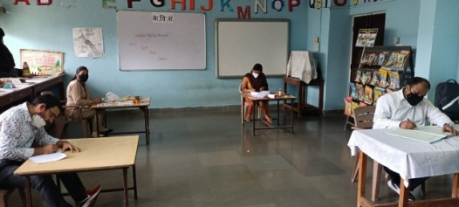
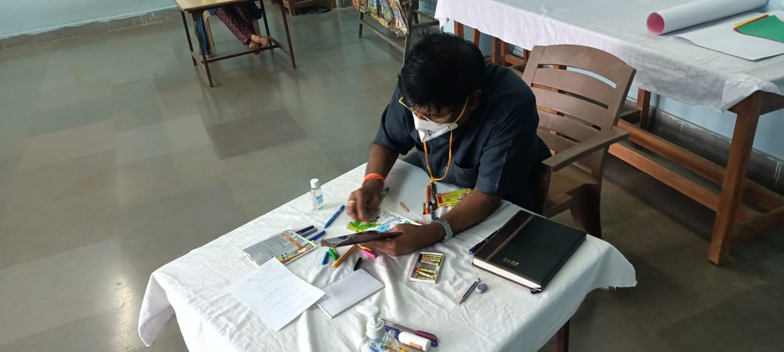
Education is the key to the success. But that success can only be achieved when children take active participation in teaching learning process. To ensure that child is attracted toward the learning process teachers make colorful teaching learning materials (TLMs). Even our beloved principal sir also becomes the part of this activity. Mr. Vinayak.R.KAttimani (principal) encouraged the teacher by sitting and making the TLMs along with primary teacher in the resource room. The creation of TLMs started from 14-7-2021 (Wednesday) and so far we have created more than 50 need based TLMs that are part of resource room. Teacher come and gets the TLM issued in their name as per requirement for the lesson. In this situation of pandemic teacher teaching particular subject of particular class come and sitting with social distancing while creating TLMs in resource room. This is just the beginning we hope by the end of this academic year 2021-22 we will be creating around 200 TLMs.
