KENDRIYA VIDYALAYA
NEAR SOMESHWAR TEMPLE, DHARWAD
REPORT ON FUNDAY ACTIVITIES
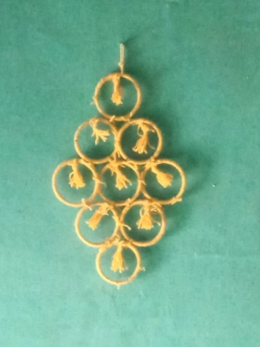
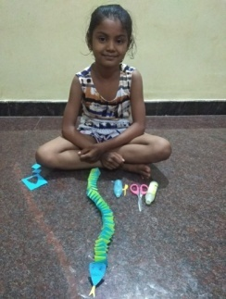
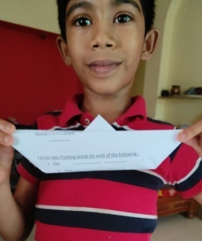
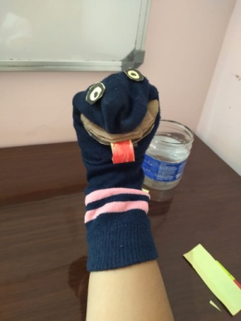
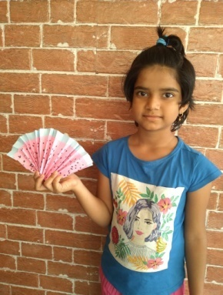
Kendriya Vidyalaya, Dharwad is a unique school in its own way that focuses on the all round development of the child. Due to pandemic, we conducted the teaching learning process in form of performing activities by celebrating FUNDAY on every Saturday through online medium via google meet app in academic session 2021-22 from. KV, Dharwad excels in making children learn new stuff every Saturday. Activities such as Storytelling, Art & craft, sing song session, Origami, Drawing, Virtual games, identifying the picture, Thumb painting etc are part of FUNDAY time table. Our beloved principal Mr.Vinayak.R.Kattimani never forgets to motivates the primary teachers for their hard work. His thoughts bring the positivity among all to perform excellent. FUNDAY activities bring lots of change in children’s’ behavior and critical thinking. Activities let the children to enjoy as well learn the new things. In this situation of pandemic we hope this all should end soon so that children will come back to school.
